Nama : Talitha Ayu Prasafa NIM : 17050623009 Prodi : D3 – Manajemen Informatika

1. 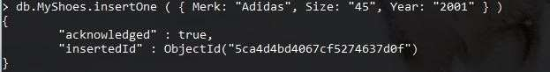InsertOne

InsertMany

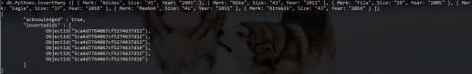

HasilOne

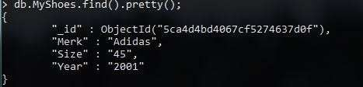

HasilMany

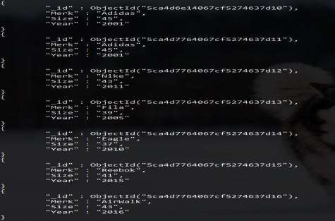

1. Query



1. Update
2. 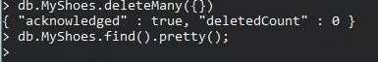Delete